Name : Saurabh Jadhav

Topic : Docker link

Assignment no. : 6

1. Install docker and create running mysql container.

Yum install docker

Systemctl start docker

Systemctl enable docker

Docker run –name Saurabh-mysql-27 -d -e MYSQL_ROOT_PASSWORD=Saurabh mysql:5

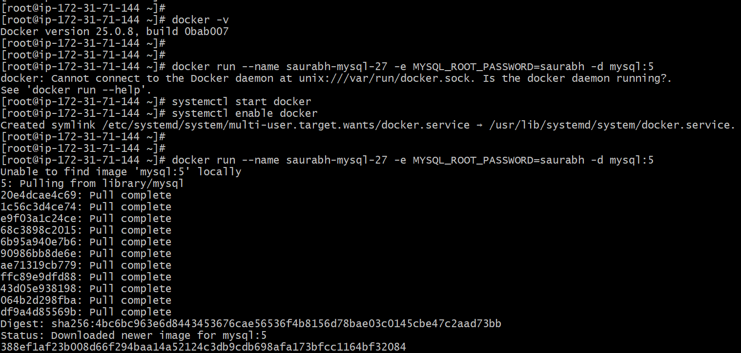

1. Execute the container and run mysql commands.

Docker exec -it <container-id> bash

Mysql -u root -p

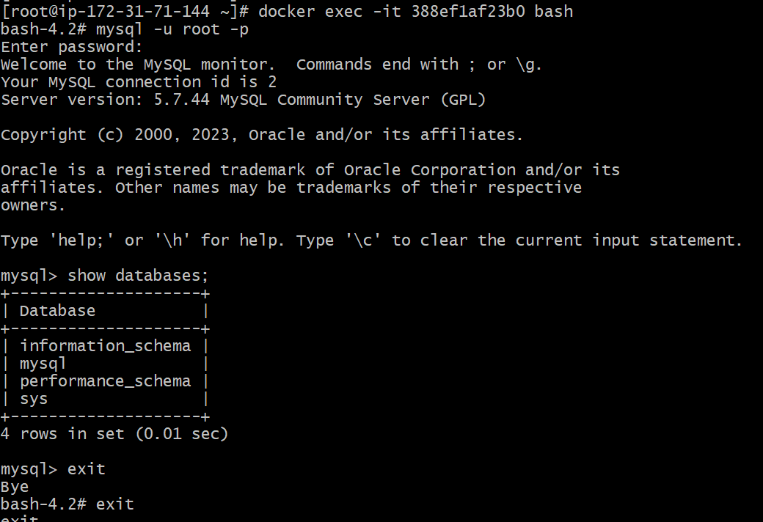

1. Run another wordpress container and link it to mysql container.

Docker run –name wordpress-1 -d -p 5050:80 –link Saurabh-mysql-27:mylink wordpress

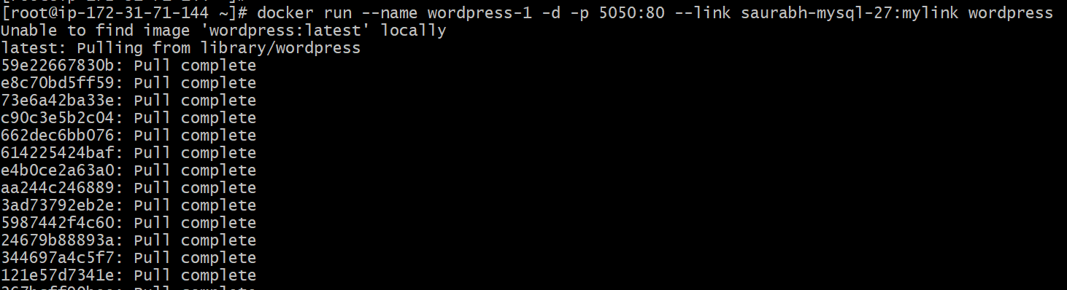

1. Finally we are able to access the wordpress website.

1. Similarly linked 2 busybox and checked the connectivity.

Docker run –name cont-1 -it busybox -----------🡪 create container 1

Press Ctrl+p+q ---------🡪 Keeps the container running and exists

Docker run –name cont-2 –link cont-1:mylink -it busybox --🡪 Create container 2

Ping cont-1 --------------------🡪 Check the connectivity

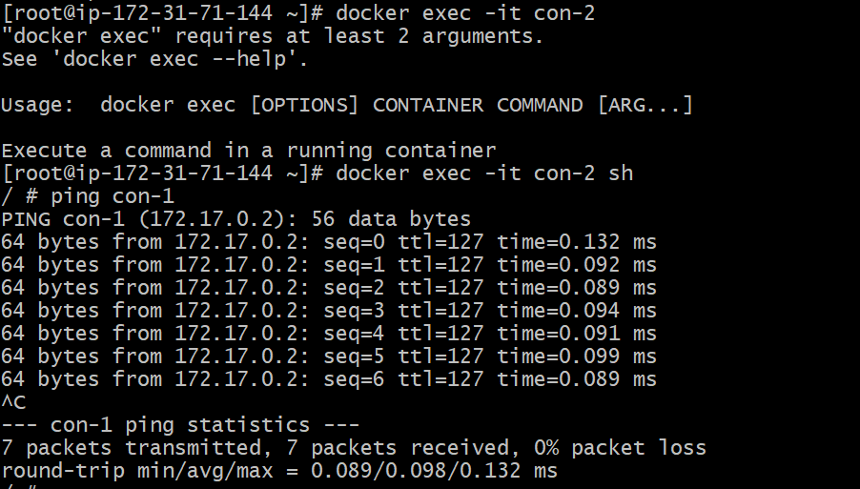

1. Inspect the details about the images.

Docker inspect <img-id> ---------🡪 provide information about image like ports , env variables etc.

